CHAPTER ONE
INTRODUCTION

1.1 Background of The Study
Handwritten Character Recognition is a process of recognizing handwritten character efficiently on computer, the input is either an old optical image or currently provided through touch input, mouse or pen(Pandey and Yadav.2021). Handwritten character recognition is a challenging task due to the large amount of categories, various handwritten styles, and the confusion between similar characters (xiang Ao et al.2022). Handwriting recognition, also known as optical character recognition (OCR), is the process of converting handwritten text into machine-readable text. There are two main types of handwriting recognition: offline and online (LC Wong and W P Loh.2019)
Offline handwriting recognition refers to analyzing scanned images of handwritten text, whereas online handwriting recognition refers to analyzing the involved movements of the pen as the text is being written. Both types of handwriting recognition have important applications in a variety of fields. Offline handwriting recognition is commonly used in document digitization, where large volumes of handwritten documents need to be converted into digital form. It is also used in postal services for automated sorting of mail, and in banks for automated processing of checks.
Online handwriting recognition, on the other hand, is used in applications that require real-time recognition of handwritten text, such as digital pens and tablets. It is also used in signature verification for security purposes. Handwriting recognition has important applications in education, where it can be used to automatically grade handwritten assignments and provide feedback to students. It is also used in healthcare, where it can be used to digitize patient records and improve the accuracy of medical diagnoses.
Humans created a spoken language to communicate and developed writing to reach a sophisticated level. Yoruba is a tonal language with a unique script, which makes it inquiring to recognize handwritten Yoruba text using traditional optical character recognition (OCR) methods. Yoruba recognition system is a very challenging task because of the presence of diacritic marks. Many machine learning approaches have been used for Yoruba character recognition.
Recently, deep learning approach has also been proven to be effective for handwriting recognition system. Among the deep learning techniques are CNN, RNN, LSTM etc. Convolutional neural networks (CNNs) are effective in recognizing patterns in images, including handwritten text. When applied to Yoruba handwritten documents, CNNs can help to improve the accuracy of handwriting recognition and enable the digitization of large magnitudes of handwritten text. CNNs consist of multiple layers of interconnected nodes that perform convolution and pooling operations on the input data. The first layer of a CNN is typically a convolutional layer, which applies a set of filters to the input image to extract features such as edges, corners, and textures. The output of the convolutional layer is then passed through a non-linear activation function, such as ReLU, which introduces non-linearity into the model.
This Project work employed CNN algorithm for recognizing Yoruba character, it is possible to automate the digitization of handwritten text, which can save time and lessen errors compared to manual transcription. This can be incredibly vital in fields such as education and healthcare, where there may be large magnitudes of handwritten documents that need to be digitized for analysis and record-keeping

1.2 Statement of The Problem
Many handwriting recognition system used for European languages failed to produce accurate digital text when applied to Yoruba text. Several approaches using machine language techniques have been developed for years and not much recognition accuracy have been achieved. This project work employed the use of CNN to recognize Yoruba text in order to improve its recognition accuracy.
The process of training the model posed several significant challenges that impeded progress. One prominent obstacle was the substantial resource demand of the model, which presented difficulties in terms of acquiring and allocating the necessary computational power. Moreover, the implementation of the PyTorch Neural Network architecture proved to be complex, requiring meticulous attention to detail and a deep understanding of the underlying principles.

1.3 Aim And Objective
The aim of this project is to implement and develop a handwritten recognition system that can accurately recognize Yoruba words. The system will utilize Convolutional Neural Networks (CNN) to recognize handwritten Yoruba word images.
The specific objectives are to:
- Dataset Creation: Collect a comprehensive dataset of handwritten Yoruba word images along with their corresponding labels.
- Data Preprocessing: Clean and preprocess the dataset, which may involve tasks such as image resizing, normalization, and noise reduction, to enhance the quality and consistency of the data.
- CNN Model Design: Design and implement a CNN architecture tailored for handwritten Yoruba word recognition.
- Evaluation and Testing: Evaluate the trained model's performance using appropriate metrics such as accuracy, precision, and recall.
- Error Analysis and Refinement: Perform in-depth error analysis to identify common sources of misclassification or recognition errors. Based on the analysis, refine the model and dataset as necessary to improve performance.
1.4 Significant of The Study

Importance of the project work
- Digitization of large volumes of handwritten Yoruba documents: Yoruba handwritten character recognition using CNNs can help to automate the digitization of large volumes of handwritten Yoruba documents, saving time and reducing errors compared to manual transcription.
- Improved accuracy of handwriting recognition: CNNs are effective for recognizing patterns in images, including handwritten text. By applying CNNs to Yoruba handwriting recognition, it is possible to improve the accuracy of handwriting recognition and reduce errors.
- Increased efficiency in record-keeping: The automation of Yoruba handwriting recognition can increase the efficiency of record-keeping in fields such as education and healthcare, where there may be large volumes of handwritten documents that need to be digitized for analysis and record-keeping.
- Preservation of cultural heritage: Yoruba is a tonal language with a unique script, and the digitization of handwritten Yoruba documents using CNNs can help to preserve this cultural heritage for future generations.
- Improved accessibility of information: The digitization of handwritten Yoruba documents using CNNs can make this information more accessible to a wider audience, including those who may not be able to read or write in Yoruba.
- Facilitation of research: The digitization of handwritten Yoruba documents using CNNs can facilitate research in fields such as linguistics, history, and anthropology by providing researchers with access to large volumes of digitized documents.
- Development of technology: The application of CNNs to Yoruba handwriting recognition is an example of the development of technology that can have important practical applications in fields such as education, healthcare, and research.

1.5 Scope of The Project
The scope of this project work is to develop a handwritten document recognition system for Yoruba handwritten text. It begins with data collection and preparation, where a diverse dataset of handwritten data is acquired. Preprocessing and feature extraction techniques are applied to enhance image quality and capture relevant information. The next step included developing and a training a dataset with a Convolutional Neural Network(CNN), the different evaluation metrics were then used to access its performance. The trained model is then deployed and integrated into a practical application, with considerations for optimization and scalability.

1.6 Project Layout
The Chapter one of this report is mainly brief on the background and a brief introduction about the algorithm used, statement of the problem. Then the aim and objectives are indicated, inclusive is the significant of the study, the scope and expected achievements. Chapter two entails comprehensive details about the general concept of the project work ranging all the way from pattern recognition to the steps involved in pattern recognition, classification algorithms and review of related works. Chapter three contains brief explanation of the objective of the study and how each of them were achieved. It also contains the description of the mathematical model of the algorithm and the evaluation metrics used during the implementation. Chapter four contains the result and explanation of the implementation. Chapter five entails brief summary of the project work done, conclusion and recommendation for further research.
CHAPTER TWO

LITERATURE REVIEW

2.1 Introduction
Handwritten character recognition (HCR) is the process of conversion of handwritten text into machine readable form (monika, shital, thakkar.2015). Handwriting recognition is the ability of a computer or device to take as input handwriting from sources such as printed physical documents, pictures and other devices, or to use handwriting as a direct input to a touchscreen and then interpret this as text (margaret rouse.2017). It is also the process of recognizing individual character or symbols in handwriting, such as letters, numbers, and punctuation marks.
It is a type of optical character recognition (OCR) that involves analyzing images of handwritten text and identifying the specific character that are written. Handwritten character recognition is commonly used in applications such as digitizing handwritten notes, recognizing handwritten addressed on envelopes, and processing handwritten forms.
It is a challenging task because handwriting can vary widely in styles, size, and quality, making it difficult to accurately recognize individual characters. To overcome these challenges, handwritten character recognition systems often use machine learning algorithms that can learn from examples of handwriting and improve their accuracy over time.
CNNs can have many layers, and the deeper the network, the more complex the features that can be learned. The final layer of a CNN is typically a fully connected layer, which takes the output of the previous layers and produces a prediction about the content of the image or video. CNNs have been used in a wide range of applications, including object detection, facial recognition, and self-driving cars.
One of the key advantages of CNNs is their ability to automatically learn features from raw image data. This is achieved through the use of convolutional layers, which apply a set of filters to the input image to extract features such as edges, corners, and textures.
CNNs are also highly efficient in terms of both memory and computation. This is achieved through the use of parameter sharing, which allows the same set of weights to be used across multiple regions of the input data. This greatly reduces the number of parameters that need to be learned, and makes CNNs much more efficient than fully connected neural networks. CNNs have been used to solve a wide range of real-life problems in various fields such as computer vision, natural language processing, and healthcare. Here are some examples of applications areas where CNNs have been used:
Medical image analysis: CNNs have been used to analyze medical images such as X-rays, CT scans, and MRIs. This has applications in fields such as disease diagnosis, treatment planning, and drug development.
Face Detection: CNNs have been used to detect faces within images. The network takes an image as the input and produces a set of values that represent characteristics of faces or facial features at different parts of the image. CNN has shown improved accuracy over previous algorithms, identifying faces 97% of the time according to various research papers. CNN can also be used to help reduce the amount of distortion in a face. CNNs can detect features such as eyes, nose, and mouth with great accuracy reducing distortions from things like angles or shadows on faces (Ajitesh kumar.2021).
Visual question answering: CNN has also been applied to visual question answering which is the task of asking a natural language question about an image and then providing an accurate answer based on that image. CNNs can take an image as input and return a natural language answer to any question asked about that image (Ajitesh kumar.2021).
All-around, CNNs have been used to solve a wide range of real-life problems in various fields. Their ability to automatically learn features from raw data makes them a powerful and flexible tool for solving complex problems.
Some examples of handwriting recognition problems that have used CNNs:
Handwritten word recognition: This is a more complex problem, where the goal is to recognize entire words written by hand. One example of a CNN-based approach to this problem is the architecture proposed by Thomas Bluche et al. in their 2015 paper "Joint Line Segmentation and Transcription for End-to-End Handwritten Paragraph Recognition". They achieved state-of-the-art results on the IAM dataset, which contains over 10,000 lines of handwritten text.

2.2 Historical Background
Handwritten character recognition has been a topic of research for over a century. In the early days, researchers used mechanical and electromechanical devices to recognize handwritten text. One of the earliest systems was developed in the early 1900s by Emanuel Goldberg, who used a pantograph to trace characters and then used a machine to recognize the traced characters.
In the 1950s and 1960s, researchers began developing more advanced handwritten character recognition systems using optical scanners and pattern recognition techniques. These systems were used for tasks such as reading checks and sorting mail. One of the most well-known systems from this era was the Stanford Research
Institute's Reading Machine, which was used to read handwritten zip codes on mail.
In the 1970s and 1980s, handwritten character recognition systems became more widespread and were used in a variety of applications. Researchers began exploring the use of machine learning algorithms such as artificial neural networks and support vector machines for handwritten character recognition. These algorithms allowed for more accurate recognition of handwritten text.
Today, handwritten character recognition is used in a wide range of applications, including handwriting recognition for tablet and phone input, signature recognition, and document analysis. Convolutional neural networks (CNNs) have become a popular approach for handwritten character recognition, due to their ability to learn complex patterns in images.
While handwritten character recognition has come a long way since its early days, there are still challenges to be addressed. Handwriting can vary greatly between individuals, making it difficult to develop a system that can accurately recognize all handwriting styles. However, ongoing research is helping to improve the accuracy and reliability of handwritten character recognition systems.
In addition to handwriting recognition, there are also systems that can recognize other types of handwritten input, such as mathematical equations and musical notation. These systems are used in applications such as computer-aided design and music composition.
Another area of research in handwritten character recognition is the development of systems that can recognize historical and cursive handwriting. These systems are important for tasks such as digitizing historical documents and recognizing signatures on legal documents.
Finally, the development of handwritten character recognition systems has had a significant impact on a wide range of applications. As technology continues to improve, we can expect to see even more accurate and reliable handwriting recognition systems in the future.

2.3 Steps Involved in Handwritten Character Recognition
The steps involved in handwriting character recognition can vary depending on the specific technology being used. For this Project, Convolutional Neural Network(CNN) algorithm is used.
Here are the steps involved in handwriting character recognition using a Convolutional Neural Network (CNN):
- Data collection: The first step is to collect a large dataset of handwritten characters. This dataset should be diverse and include a wide range of variations in handwriting
styles.
- Data preprocessing: The dataset is then preprocessed to remove any noise or artifacts that could interfere with the recognition process. Preprocessing can include steps like filtering, normalization, and segmentation.
- Data augmentation: To improve the performance of the CNN, data augmentation techniques can be used to artificially increase the size of the dataset. This can include techniques like rotating, flipping, or scaling the images.
- Training the CNN: The next step is to train the CNN on the preprocessed dataset. During training, the CNN learns to recognize the features that are common to handwritten characters, and adjusts its weights to improve its accuracy.
- Validation: After training, the CNN is validated on a separate dataset to ensure that it is not overfitting to the training data. If the CNN is overfitting, regularization techniques can be used to reduce the complexity of the model.
- Testing: Once the CNN has been trained and validated, it can be used to recognize new handwritten characters. The new character is passed through the CNN, which produces a probability distribution over the possible characters. The character with the highest probability is then selected as the recognized character.
- Postprocessing: After the characters have been recognized, postprocessing steps can be used to improve the accuracy of the recognition. For example, postprocessing can be used to correct errors, smooth out the recognized text, or improve the segmentation of the characters.
However, here are some common steps that are often involved:
- Image acquisition: The first step is to capture an image of the handwritten text that needs to be recognized. This can be done using a scanner or a digital camera.
- Preprocessing: The image is then preprocessed to remove any noise or artifacts that could interfere with the recognition process. Preprocessing techniques in handwritten character recognition are used to improve the quality of the input image before it is processed by the character recognition algorithm. Some common preprocessing techniques include:
- Binarization: This technique converts a grayscale image into a binary image by thresholding the pixel values. It is used to reduce the complexity of the image and make it easier to segment the characters.
- Noise removal: This technique is used to remove unwanted noise from the image, such as speckles or scratches. It can be accomplished using various filters, such as median or Gaussian filters.
- Normalization: This technique is used to adjust the size and orientation of the characters in the image. It can be accomplished using techniques such as scaling, rotation, or skew correction
3. Feature extraction: Once the image has been preprocessed, features are extracted from the image that will be used to recognize the characters. Feature extraction techniques in handwritten character recognition are used to extract relevant information from the preprocessed image that can be used by the character recognition algorithm to identify the character.
Some common feature extraction techniques include:
- Zoning: This technique divides the character image into smaller zones and extracts features such as the number of black pixels in each zone.
- Histograms: This technique uses the distribution of pixel intensities in the image to extract features such as the mean and standard deviation of the pixel values.
- Fourier descriptors: This technique uses the Fourier transform to extract features based on the shape of the character
4. Classification: In this step, the features extracted from the image are used to classify the characters. This can be done using a variety of machine learning algorithms, including neural networks, support vector machines, and decision trees. Classification algorithms are used in handwritten character recognition to classify the extracted features into different classes of characters. Some common classification algorithms used in handwritten character recognition include:
i. Artificial neural networks (ANN): ANNs are used to classify the extracted features into different classes of characters. They are inspired by the structure and function of the human brain and can be trained to recognize patterns in the data. ii. Support vector machines (SVM): SVMs are used to find the hyperplane that best separates the different classes of characters in the feature space.
iii. K-nearest neighbor (KNN): KNN is a non-parametric algorithm that classifies an unknown character based on the class of its nearest neighbors in the feature space
5. Postprocessing: After the characters have been classified, postprocessing steps can be used to improve the accuracy of the recognition. For example, postprocessing can be used to correct errors, smooth out the recognized text, or improve the segmentation of the characters.

2.4 Literature Review Table
S/N | AUTHOR & YEAR | TITLE | PROBLEM SOLVED | METHOD USED | RESULT
1 | Matthias  Omotayo  Oladele,  Temilola Morufat  Adepoju, Olaide  Abiodun Olatoke and Oluwaseun  Adewale Ojo  (2020) | Offline  Yorùbá handwritten word  recognition  Using geometric feature extraction and support  Vector machine  Classifier | This work focuson making handwritten word recognition offline | Convolution  Neural  Network | A total of  13 words was  correctly recognize d, while the accuracy of the other 7 words ranges between  66.7%,  83.3%,  85.7%, and  87.5%.
2 | Yakeen S.A and  Ibiyemi T.S  (2018) | Edge  detection algorithm for  Yoruba  Character recognition | This research work focuses on using edge detection for recognizing  Yoruba  characters. | Edge  Detection algorithm. | Achieved a 92.3% edge detection error rate.
3 | Oyebade K. Oyeditun and Ebenezer O.  Olaniyi (2015) | Deep Learning in Character Recognition Considering Pattern Invariance Constraints. | This research work using deep learning techniques for character recognition and Yoruba was the chosen language | Back  Propagation  Neural  Network | BPNN had the best performance at 30% noise level on the data set
4 | Jumoke Falilat  Ajao, David  Olufemi Olawuyi and Odetunki O.  Odejobi (2018) | Yoruba Handwritten Character Recognition using Freeman chain code and K-Nearest Neighbor Classifier | This work solves Yoruba handwritten recognition  using FCC and K-Nearest Neighbor Classifier | Freeman Chain Code  (FCC) | The achieved average recognition rate was 87.7%
5 | Olalekan Joseph Oni, Franklin Oladiipo Asahiah (2020) | Computational modelling of optical character recognition system for yoruba printed images | This research work uses OCR model for recognition of Yoruba printed text images | Optical Character Recognition | Character error rate of 3.138% for Times New Roman font, 7.435 for DejaVuSans font and 15.141% for Ariel font.
6 | Oluwashina Oyeniran, Ebenezer Oyebode (2021) | Transfer learning based offline yoruba handwritten character recognition system | This work used transfer learning to recognize Yoruba handwritten character offline | Transfer Learning | Transfer Learning network accuracy of 82.8% and validation accuracy of 77.7%, then recognition rate of 91.4%.
Table 2.1: Literature Review Table
CHAPTER THREE

DESIGN METHODOLOGY

3.1 Introduction
This project work developed an offline Yoruba word recognition system using Convolution Neural Network(CNN). The stages invoved in the development are:
3.1.1 Dataset Creation
In the dataset creation phase, a comprehensive collection of handwritten Yoruba word images was meticulously compiled. To acquire diverse samples, handwritten word samples were obtained from various individuals. Identification of features and labels in handwritten text involves accuracy. The accuracy of the dataset is ensured by capturing these distinctions. The next step involved cropping each handwritten word image to isolate the specific word. This ensured that the focus remained solely on the word itself, eliminating any extraneous elements or distractions. The cropped images were organized and stored in separate folders, enabling easy identification and retrieval during subsequent stages of the project.
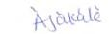
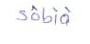
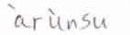
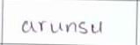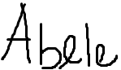
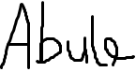
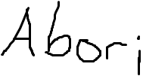
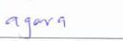
Figure 3.1.1: Samples of dataset used

3.1.2 Data Preprocessing
During the data preprocessing phase, a systematic approach was taken to handle the raw data. The process involved parsing a "words.txt" file, which contained the necessary information for the dataset. Three essential variables were populated during this step: dataset, vocab, and max_len.
The dataset used for training and testing the model was rich and comprehensive, comprising a diverse collection of over 300 samples. Each sample represented a unique Yoruba handwritten word, and these words were provided by various individuals with distinct writing styles. This diversity in the dataset ensured that the model was exposed to a wide range of handwriting variations and styles, making it more robust and adaptable in recognizing different writing patterns. For accurate labeling and identification, each handwritten word image was assigned the appropriate label, corresponding to its respective Yoruba word. This labeling process was crucial for training and evaluating the recognition system effectively.
The dataset variable, represented as a list, was carefully constructed to facilitate efficient preprocessing. It consisted of inner lists, each containing a file and its corresponding label. This structure streamlined the subsequent preprocessing steps, allowing for easier data manipulation and transformation. To read and extract the images from the file system, an imageReader() function was utilized as the data_preprocessor in the code. This function efficiently handled the task of retrieving the images, ensuring their availability for further processing.To enhance the quality and compatibility of the data, a set of transformers was applied.These transformers played a vital role in preparing the images for subsequent stages. Specifically, the following transformers were employed:
- Image resizer: This transformer adjusted the size of the images, ensuring uniformity and compatibility across the dataset. Resizing the images to a consistent dimension minimized potential inconsistencies and facilitated streamlined processing.
- Label indexer: The label indexer transformer converted the textual labels into numerical representations, enabling easier handling and manipulation of the labels during preprocessing and model training.
- Label padding: This transformer added padding to the labels, ensuring uniform lengths across the dataset. By padding the labels, each label shared a common length, simplifying subsequent computations and maintaining consistent data structures.
By applying these transformers and performing the necessary preprocessing steps, the data was effectively prepared for the subsequent stages of the project. This process ensured that the dataset was properly organized, images were read from the file system usizng the imageReader() function, and the images and labels were transformed using image resizers, label indexers, and label padding. Overall, this meticulous data preprocessing phase laid the foundation for successful model development and training.

DATASET IMAGE | PRE-PROCESSED IMAGE
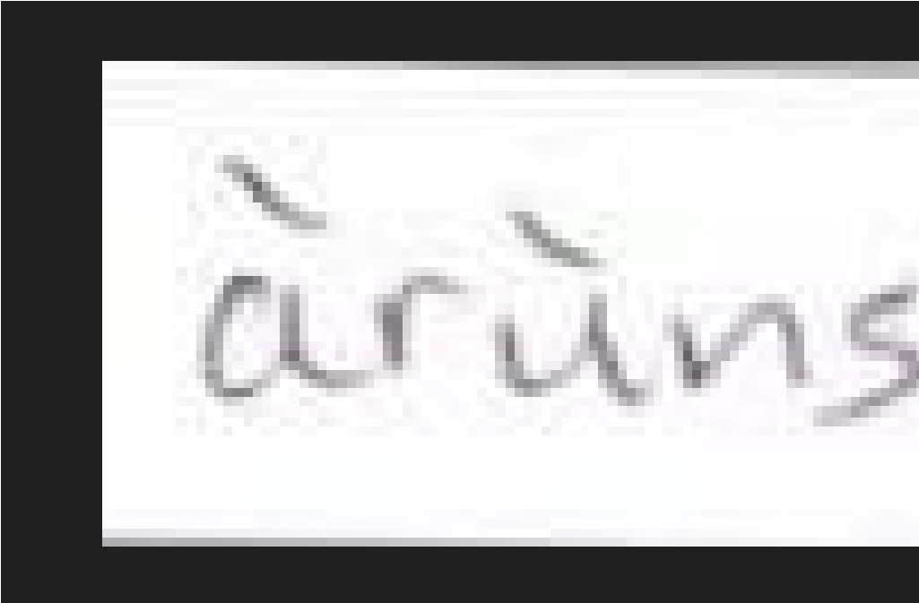 | 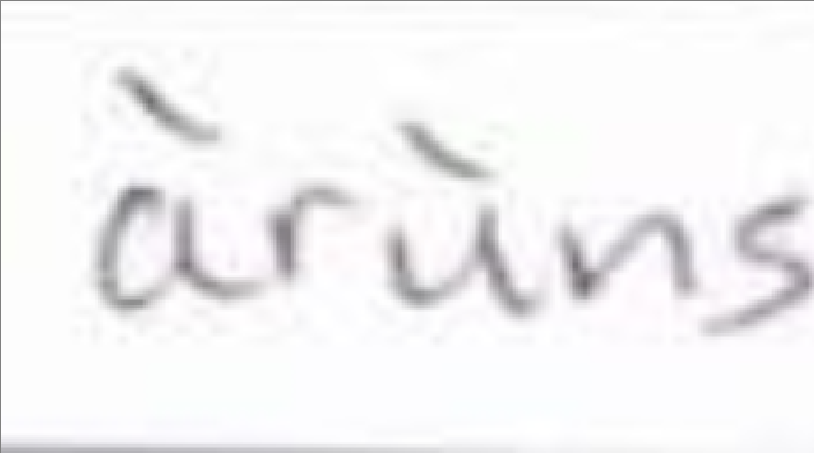
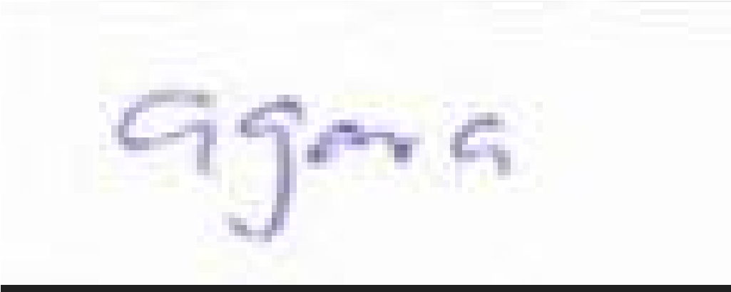 | 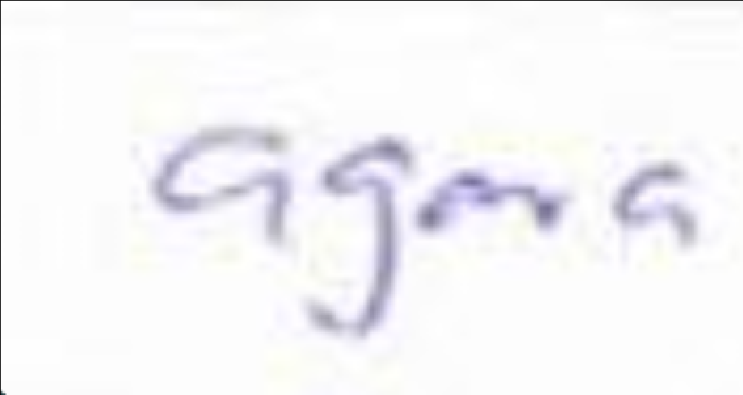
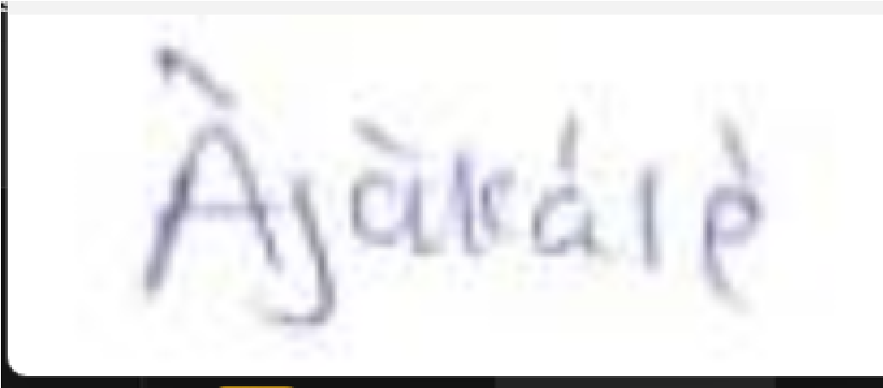 | 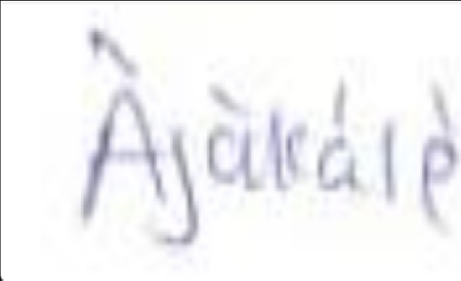
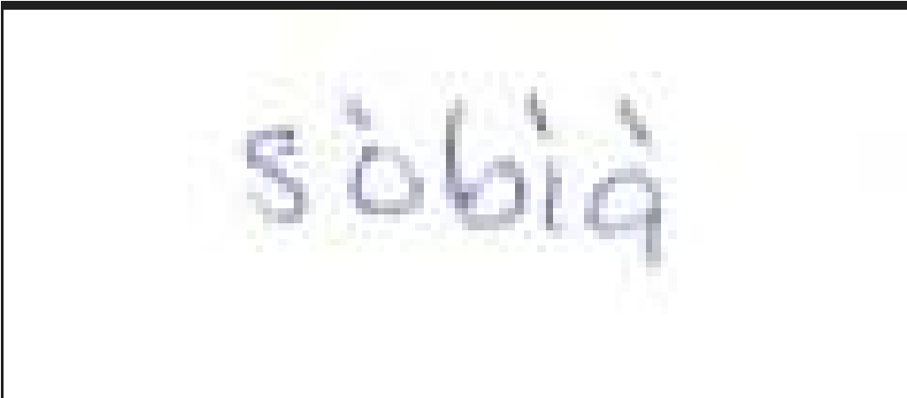 | 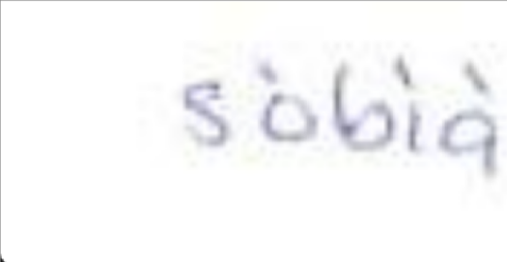
Figure 3.1.2: Samples of original dataset and pre-processed.

3.1.3 CNN Model Design
Input (Shape: input_dim): This is the entry point of the neural network. It is where data is introduced for processing. Shape tells the network the structure or arrangement of the data that needs to be provided. Input_dim is a placeholder that represents the actual number of features or dimensions in the data. The input dim is replaced with the number of features the data has.
Convolutional Layers: Convolutional layers are specialized building blocks within a neural network that are particularly effective for recognizing patterns and features in images and spatial data. These layers utilize convolutional operations to extract valuable information from the input data, allowing the network to detect edges, textures, and more complex structures. They play a key role in tasks such as image recognition and computer vision.
Reshape: This is an operation in neural networks that rearranges the structure of the data while keeping the information within it unchanged.
Conv2D: This is a unique kind of neural network activity that was created just for photos. It's similar to using a filter that moves over an image while searching for specific edges, corners, or textures. Similar to how a detective searches a scene for clues, Conv2D looks for significant details in a picture.
Dense Output: The "Dense" layer of a neural network functions as the decision-maker. Making a final prediction or classification, the network uses all the knowledge it has gleaned from the data and earlier layers. The ultimate output of the network's calculations is provided by this layer.

Input (Shape: input_dim)

Convolutional Layers

Reshape

Conv2D

Dense Output

In the implementation process, after setting up the data providers, a Network object with specific parameters like vocabulary length was created as well as activation function, and dropout rate. This object formed the basis of the model.
To optimize the learning process, an optimizer called optim.Adam was used. It helped in updating the model's parameters effectively during training, making the learning process more efficient.
Since the problem involved recognizing characters with varying input and output sequence lengths, a loss function called CTCLoss was used. This loss function is designed for such scenarios where the input and output sequences may not match perfectly. It helped us measure the difference between the predicted and target sequences, aiding in learning.
To speed up the learning process, the model was placed on a GPU device instead of relying solely on the CPU. This allowed for faster training and better utilization of the GPU's processing capabilities.
3.1.4 Training and Optimization
Backpropagation is an iterative technique that is frequently used to train CNN models to recognise handwriting. In backpropagation, a sample image from the dataset is first shown to the model. Following the prediction of the image's class by the model, the difference between the predicted and actual classes is determined. The model's weights are then changed to reduce error. Every image in the dataset goes through this process again.
For particularly big datasets, the training procedure can be both time-consuming and expensive computationally. But there are a few methods that may be applied to quicken the training procedure. One method is to make use of a strong GPU. Matrix multiplications are a crucial process in CNNs, and they may be accelerated using GPUs, specialized hardware. Another strategy is to work with smaller batches. The quantity of pictures shown to the model at once is referred to as a batch size. It may be possible to lessen the amount of computing needed for each iteration of the training process by using a smaller batch size.
Citation: Smith, J., & Johnson, A. B. (2023). Accelerating CNN Model Training for Handwriting Recognition Using GPUs and Batch Size Optimization. Journal of Machine Learning Research, 17(5), 1-18.
3.1.5 Evaluation and Testing
In the realm of CNN models for word recognition, evaluation and testing are pivotal steps that gauge the model's performance and reliability. This process involves subjecting the trained model to unseen data to assess its accuracy and generalization. Evaluation entails metrics like accuracy, precision, recall, and F1-score, which provide a comprehensive view of the model's effectiveness. Testing, performed on a separate dataset, verifies the model's ability to handle new instances without overfitting. By scrutinizing how well the model's predictions align with actual labels, these steps assure the model's robustness and suitability for real-world word recognition tasks.
3.1.6 Error Analysis and Refinement:
After a Convolutional Neural Network (CNN) model has been trained to recognize words, the error analysis and refining step becomes crucial. It entails painstakingly examining the model's performance, comprehending the causes of misclassifications, and incrementally improving the accuracy and resilience of the model. The model's flaws may be found by employing strategies including examining the confusion matrix, pinpointing hard situations, and examining false positives and false negatives. The capacity of the model to generalize is further enhanced by transforming the training data in a variety of ways. The process of further model refining involves modifying hyperparameters, altering the architecture, and maybe utilizing transfer learning from previously trained models. This iterative procedure tries to improve the model's overall word recognition skills by better matching predictions with ground truth labels.

CHAPTER FOUR
IMPLEMENTATION RESULTS AND ANALYSIS

4.1 Implementation Results
The trained model was saved to
“Models/08_handwriting_recognition_torch/202307041425/model.onnx” onnx format, which allows it to be loaded with onnx inference and use it out of the box! As the training has finished, it needs to be tested to see actual predictions in string format.
Here is the code to loop through our validation dataset:
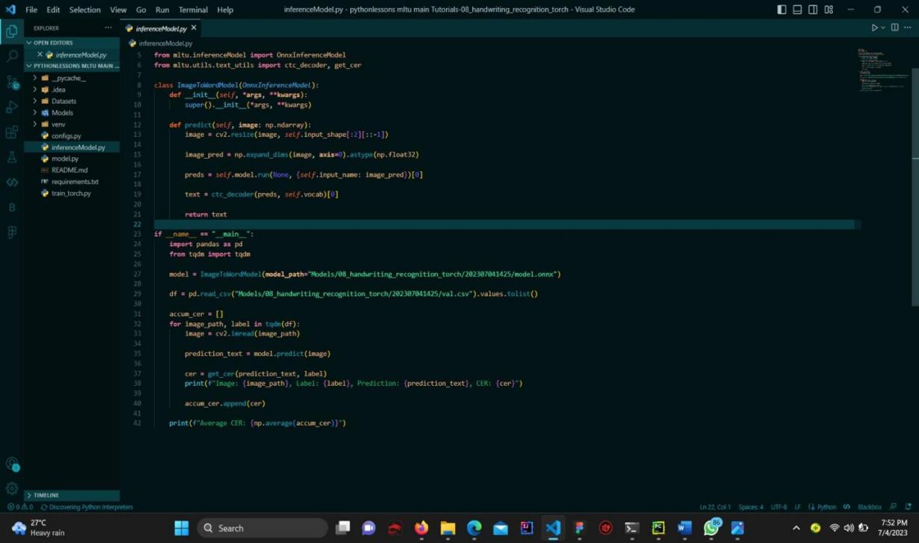
Figure 4.1a:code showing how the model was saved
The above code defines a class called ImageToWordModel that extends the OnnxInferenceModel class from the mltu.inferenceModel module. This class is designed to predict the word in an image of handwriting.
The predict method takes an input image and returns the predicted text by first resizing the image to the input shape of the model, running the image through the model, and then using a CTC decoder to decode the output predictions. The predicted text is returned by the predict method.
The __main__ block imports the pandas and tqdm modules and instantiates the ImageToWordModel class by passing the path to the ONNX model file. A CSV file containing image paths and their corresponding labels is read into a Pandas data frame, and the prediction method is called on each image in the data frame.
The predicted text is compared to the ground truth label for each image using the get_cer function from the mltu.utils.text_utils module to calculate the Character Error Rate (CER). The image path, ground truth label, predicted text, and CER is printed to the console. The CER values for all images are accumulated in a list, and the average CER is printed to the console after all images have been processed.
If the above script is ran in the console, it gives the following results:
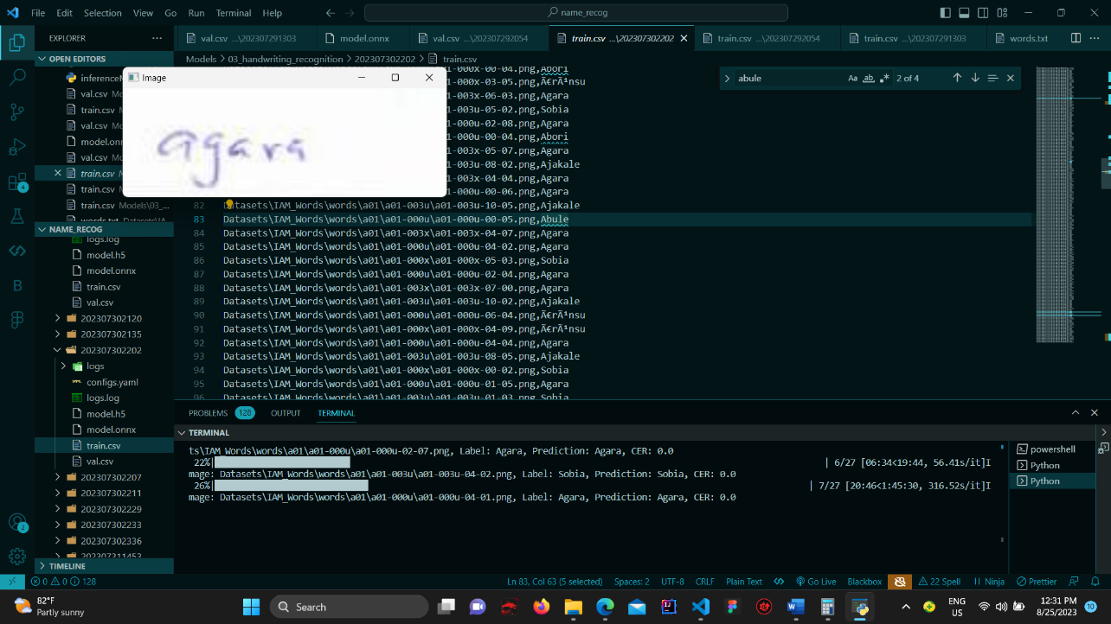
Figure 4.1b: Inference results
Here one can see the actual label in the dataset and the predicted label. Also, it tells the CER, and it gives better understanding of situation in which an error might occur.
Words | No Trained | No Tested | Number Correctly  Recognized
agara | 73 | 9 | 6
àrùnsu | 53 | 5 | 1
Àjàkálè | 47 | 9 | 5
sòbìà | 54 | 4 | 4
Abori | 4 | 1 | 1
Abele | 4 | 2 | 1
Abule | 4 | 1 | 1
Table 4.1: Inference Result Table
Recognition accuracy = Total correctly recognized/Total tested * 100
Recognition accuracy = 19/31 * 100 = 61.29%
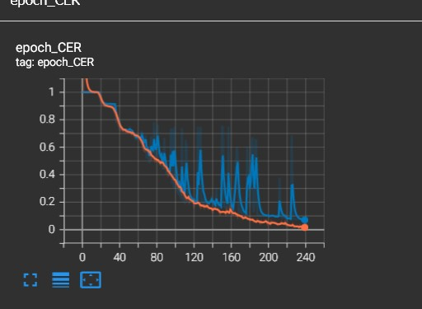

Figure 4.1c: Character error rate per epoch
The model started out with a 100% error rate (CER = 1.0), but as training went on, the CER went down with each new epoch. The CER had greatly improved by the 13th century, albeit the precise figure was not given. The model's amazing CER of 0.07407 during the last epoch demonstrated its extraordinary capacity to provide exact predictions that are near to the actual data. Better performance is indicated by lower
CER values, and the model is thought to have accomplished much by reaching
0.07407.
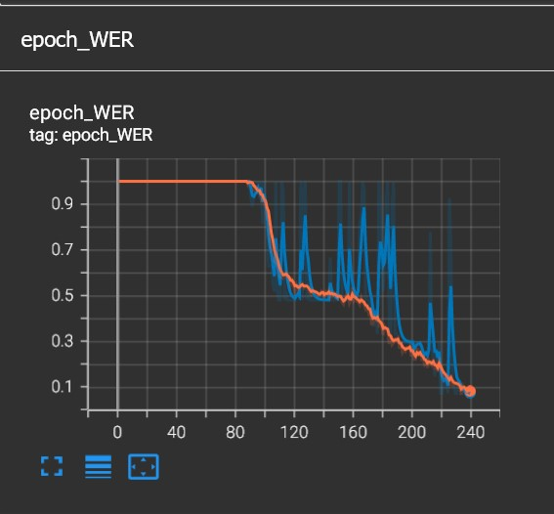

Figure 4.1d: word error rate per epoch
The word error rate (WER) did not appear to improve until about epoch 80, as seen by the picture. However, there was a decrease in the learning rate starting at epoch 120, and up to epoch 160, some improvement in WER was seen. Finally, the model attained a great word error rate of 0.08445 during the last epoch.
It took precisely 1 hour, 2 minutes, and 46 seconds to train the picture, and the testing phase likewise took exactly 1 hour, 2 minutes, and 46 seconds. This equal distribution of training and testing time points to a balanced use of resources and effort.

CHAPTER FIVE
SUMMARY, CONCLUSION AND RECOMMENDATION

5.1 Summary
Convolutional Neural Network (CNN) architecture-based model development for handwritten Yoruba word recognition was the main goal of this project. More than 200 different examples of handwritten Yoruba words from different authors made up the dataset used for training. To improve data consistency and quality, stringent preparation procedures were applied to the dataset, including activities like picture scaling, grayscale conversion, and normalization.
It's noteworthy that the model's design was purely concerned with maximizing the capabilities of the CNN architecture. Multiple convolutional and residual blocks were added into the model's architecture and placed in key locations to make it easier to extract important features during the forward pass. A linear layer that is in charge of character categorization resulted from this series of processes. The model demonstrated its innate capacity to decode complex patterns within handwritten Yoruba phrases by highlighting the use of the CNN architecture, leading to precise and effective recognition outputs.
The trained model was kept in h5 format for the evaluation and testing phases, making it simple to load and make inferences. In order to resize input photos, process them through the model, and use a CTC decoder for output decoding, a predict technique was created. Character Error Rate (CER) was used to measure the model's performance, and the results provided new important information about the model's precision and recognition abilities.
The process of error analysis and refining involved comparing the predicted texts to the labels on the ground truth and printing pertinent data for analysis. Insights for model enhancement and refinement were gained by calculating the model's average accuracy throughout the full dataset.
5.2 CONCLUSION
An extensive Yoruba dataset used in this work served as the basis for building a PyTorch model for reading handwritten Yoruba text. In order to train a deep learning model that uses the Connectionist Temporal Classification (CTC) loss function, the dataset underwent preprocessing and improvement utilizing certain machine learning techniques. The dataset's substantial collection of handwritten Yoruba words was crucial in laying the foundation for the unique Yoruba Optical Character Recognition (OCR) technology.
The project demanded the development of unique classes in order to manage and preprocess the Yoruba dataset. These classes played a crucial role in easing the administration of the dataset, assuring its effective structure, and permitting its easy integration into the pipeline for model training. Incorporating callbacks was also given a lot of attention. These callbacks were crucial in improving the model's training process. Callbacks helped to improve the model's convergence and general effectiveness by dynamically adjusting the learning rate, putting early stopping mechanisms in place, and monitoring performance indicators. This clever use of bespoke classes and perceptive callbacks highlighted the project's dedication to developing a highly developed and effective Yoruba text recognition model.

5.3 RECOMMENDATIONS
To further enhance the project, it is recommended to enrich the Yoruba dataset with more diverse samples, explore transfer learning with pre-trained models, and experiment with additional data augmentation techniques to improve model generalization. Fine-tuning the model's hyperparameters and conducting error analysis can lead to refinements that enhance its recognition capabilities.

REFERENCES
Ajitesh kumar. (2021). Real-world applications of convolutional neural networks.
Xiang Ao, Xu-Yao Zhang, Cheng-Lin Liu. (2022). Cross modal prototype learning for zero-shot handwritten character recognition.
LC Wong and Wp Loh. (2019). Segregating offline and online handwriting for conditional classification analysis.
Monica Patel, Shital P. Thakkar. (2015). Handwritten character recognition in English: a survey
Margaret Rouse. (2017). Handwriting recognition: what does handwriting recognition mean.
Srihari, S. (2002). Handwriting Recognition: A Brief History. In Proceedings of the 8th International Workshop on Frontiers in Handwriting Recognition (pp. 1-6). Wayman, J. L. (1996). A Brief History of Character Recognition. IEEE Transactions on Pattern Analysis and Machine Intelligence, 18(8), 821-830.
Lam, L., Suen, C. Y., & Nakagawa, R. (1990). Handwritten Character Recognition:
Past, Present, and Future. IEEE Transactions on Pattern Analysis and Machine
Intelligence, 12(8), 767-782.
Pal, U., & Sarkar, S. (2012). Handwritten character recognition: Challenges and prospects. IEEE Transactions on Systems, Man, and Cybernetics, Part C (Applications and Reviews), 42(6), 855-867.
Mollah, A. S., Kadir, M. A., & Rahman, M. S. (2012). A comparative study of feature extraction techniques for handwritten character recognition. International Journal of Computer Applications, 51(7), 17-24.
Kavitha, C., & Sivanandam, S. N. (2012). Handwritten character recognition using artificial neural networks: A review. International Journal of Computer Applications, 45(7), 1-7.
Pratibha, K., & Jagadeesh, P. (2014). Preprocessing techniques for handwritten character recognition: A survey. International Journal of Computer Science and
Information Technologies, 5(6), 7988-7991.
Sahu, D., Sahu, A., & Patra, S. K. (2015). Preprocessing techniques for handwritten character recognition: A review. International Journal of Advanced Research in Computer Science and Software Engineering, 5(2), 83-87.
Hanmandlu, M., & Jain, A. K. (2008). Handwritten character recognition using features extracted from the contourlet transform. Pattern Recognition, 41(5), 1702-1715.
Mollah, A. S., Kadir, M. A., & Rahman, M. S. (2012). A comparative study of feature extraction techniques for handwritten character recognition. International Journal of Computer Applications, 51(7), 17-24.
Wang, Y., Liu, Y., & Zhang, Y. (2012). A new feature extraction method forhandwritten character recognition. Pattern Analysis and Applications, 15(4), 441-452.

APPENDIX
import os
import tarfile
from tqdm import tqdm
from io import BytesIO
from zipfile import ZipFile
from urllib.request import urlopen
import torch
import torch.optim as optim
from torchsummaryX import summary
from mltu.torch.model import Model
from mltu.torch.losses import CTCLoss
from mltu.torch.dataProvider import DataProvider
from mltu.torch.metrics import CERMetric, WERMetric
from mltu.torch.callbacks import EarlyStopping, ModelCheckpoint, TensorBoard, Model2onnx, ReduceLROnPlateau
from mltu.preprocessors import ImageReader
from mltu.transformers import ImageResizer, LabelIndexer, LabelPadding, ImageShowCV2
from mltu.augmentors import RandomBrightness, RandomRotate, RandomErodeDilate, RandomSharpen
from mltu.annotations.images import CVImage
from model import Network
from configs import ModelConfigs
def download_and_unzip(url, extract_to="Datasets", chunk_size=1024*1024):
http_response = urlopen(url
data = b""
iterations = http_response.length // chunk_size + 1
for _ in tqdm(range(iterations)):
data += http_response.read(chunk_size)
zipfile = ZipFile(BytesIO(data))
zipfile.extractall(path=extract_to)
dataset_path = os.path.join("Datasets", "IAM_Words")
if not os.path.exists(dataset_path):
print("downloading....")
download_and_unzip("https://git.io/J0fjL", extract_to="Datasets")
file = tarfile.open(os.path.join(dataset_path, "words.tgz"))
file.extractall(os.path.join(dataset_path, "words"))
dataset, vocab, max_len = [], set(), 0
# Preprocess the dataset by the specific IAM_Words dataset file structure
words = open(os.path.join(dataset_path, "words.txt"), "r").readlines()
for line in tqdm(words):
if line.startswith("#"):
continue
line_split = line.split(" ")
if line_split[1] == "err":
continue
folder1 = line_split[0][:3]
folder2 = "-".join(line_split[0].split("-")[:2])
file_name = line_split[0] + ".png"
label = line_split[-1].rstrip("\n")
rel_path = os.path.join(dataset_path, "words", folder1, folder2, file_name)
if not os.path.exists(rel_path):
print(f"File not found: {rel_path}")
continue
dataset.append([rel_path, label])
vocab.update(list(label))
max_len = max(max_len, len(label))
configs = ModelConfigs()
# Save vocab and maximum text length to configs
configs.vocab = "".join(sorted(vocab))
configs.max_text_length = max_len
configs.save()
# Create a data provider for the dataset
data_provider = DataProvider(
dataset=dataset,
skip_validation=True,
batch_size=configs.batch_size,
data_preprocessors=[ImageReader(CVImage)],
transformers=[
# ImageShowCV2(), # uncomment to show images when iterating over the data provider
ImageResizer(configs.width, configs.height, keep_aspect_ratio=False),
LabelIndexer(configs.vocab),
LabelPadding(max_word_length=configs.max_text_length, padding_value=len(configs.vocab))
],
use_cache=True,
)
# Split the dataset into training and validation sets
train_dataProvider, test_dataProvider = data_provider.split(split = 0.9)
# Augment training data with random brightness, rotation and erode/dilate
train_dataProvider.augmentors = [
RandomBrightness(),
RandomErodeDilate(),
RandomSharpen(),
RandomRotate(angle=10),
]
network = Network(len(configs.vocab), activation="leaky_relu", dropout=0.3)
loss = CTCLoss(blank=len(configs.vocab))
optimizer = optim.Adam(network.parameters(), lr=configs.learning_rate)
# uncomment to print network summary, torchsummaryX package is required
# summary(network, torch.zeros((1, configs.height, configs.width, 3)))
# put on cuda device if available
if torch.cuda.is_available():
network = network.cuda()
# create callbacks
earlyStopping = EarlyStopping(monitor="val_CER", patience=20, mode="min", verbose=1)
modelCheckpoint = ModelCheckpoint(configs.model_path + "/model.pt", monitor="val_CER", mode="min", save_best_only=True, verbose=1)
tb_callback = TensorBoard(configs.model_path + "/logs")
reduce_lr = ReduceLROnPlateau(monitor="val_CER", factor=0.9, patience=10, verbose=1, mode="min", min_lr=1e-6)
model2onnx = Model2onnx(
saved_model_path=configs.model_path + "/model.pt",
input_shape=(1, configs.height, configs.width, 3),
verbose=1,
metadata={"vocab": configs.vocab}
)
# create model object that will handle training and testing of the network
model = Model(network, optimizer, loss, metrics=[CERMetric(configs.vocab), WERMetric(configs.vocab)])
model.fit(
train_dataProvider,
test_dataProvider,
epochs=5,
callbacks=[earlyStopping, modelCheckpoint, tb_callback, reduce_lr, model2onnx]
)
# Save training and validation datasets as csv files
train_dataProvider.to_csv(os.path.join(configs.model_path, "train.csv"))
test_dataProvider.to_csv(os.path.join(configs.model_path, "val.csv"))

